

The Dick Howser Center

3519 Easter Stanley Court

Tallahassee, FL 32308

Phone 850-921-5437

Fax 850-921-4734

E-mail ksineath@goodwillbigbend.com



united way logo.gif

Volunteer

Handbook

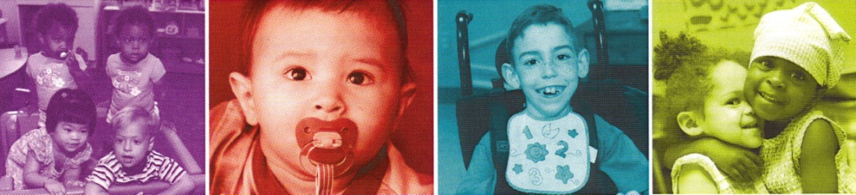Welcome

Our Mission is to improve the lives and acceptance of children with special needs and their families

Thank you for choosing to volunteer your time here at The Dick Howser Center for Childhood Services. The Dick Howser Center strives to create a unique and inclusive atmosphere where children with varying gifts and abilities enjoy a nurturing and natural environment designed to encourage the growth of both self-esteem and personal independence.

To get you ready for your volunteer experience we have created this volunteer handbook. We hope that your time with us at The Dick Howser Center is both inspiring and educational.

As a volunteer, you are required to abide by all policies of DHC and to honor your commitment to service. If at any time you have a problem related to your work, please contact Kim Streb, Administrative Program Director at 850-671-3569 or kstreb@goodwillbigbend.com.



j0442060

DISCIPLINE POLICY

The intent of this policy is to prevent misbehavior, rather than simply “react” to it. Instead of punishing children after they have misbehaved, the environment should be set up so that children will be less likely to misbehave. This means that certain conditions should be kept in mind: enough toys, enough space, enough activities, enough time, etc. When young children are involved in activities that they enjoy and can pursue at their own rate, they are less likely to misbehave out of frustration. When they are praised and encouraged for their efforts, they are less likely to misbehave to get attention. When children are taught to play cooperatively, they are less likely to fight among themselves. In these ways, some potential problems may be anticipated and eliminated.

*Nevertheless, misbehavior will sometimes occur. At these times, Dick Howser employees and volunteers WILL USE appropriate responses:*

1. Calm, positive, and developmentally appropriate language will be used to redirect children’s behavior when necessary to other activities, toys, or play spaces.
2. Children may be reminded of the rules through a restating of the limits that we place on their behavior.
3. If misbehavior continues, older children (preschool) may be asked to sit apart from their peers until they are ready to rejoin the group.

DISCIPLINE POLICY

*Dick Howser employees and volunteers WILL NEVER USE the following inappropriate responses to misbehavior:*

1. Children under one year of age will not be disciplined in any manner.
2. Children shall not be subjected to discipline that is severe, humiliating, or frightening. This includes harsh language, verbal threats of corporal or excessive punishment, name-calling, derogatory remarks, or any action that could lower the pride, dignity, or self-respect of a child.
3. Children shall not be subjected to discipline that is associated with food. A child may not be denied meals, dessert, snacks, treats, party food, etc.
4. Children may not be denied rest as a form of discipline, nor subjected to discipline because they fail to rest at designated times.
5. Children may not be subjected to discipline that is related to toileting.
6. Children will not be subjected to discipline involving total isolation (i.e., “time-out”) or that denies them participation in special activities (i.e., field trips, parties).
7. Children will not be subjected to spanking or any other form of corporal punishment. This includes paddling a child, slapping a child on the hand or any other body part, pulling a child’s hair, arm, or other extremity, pinching a child or any other action that is painful or might cause a child bodily harm.

Phones/Media

Volunteers are not permitted to make or receive telephone calls during service hours, unless it is an emergency.

The use of cellular phones, Bluetooth devises IPODS, and MP3 players are prohibited during service hours

Harassment

The Dick Howser Center is committed to providing a work environment that is free from all forms of discrimination and conduct that can be considered harassing, coercive, or disruptive, including sexual harassment. Actions, words, jokes, or comments based on an individual’s sex, race, color, national origin, age, religion, disability, or any other legally protected characteristic will not be tolerated.

Minors:

Drugs/Alcohol/Smoking

The Dick Howser Center for Childhood Services, Inc. is committed to providing a safe environment and to fostering the well-being of our employees and our children by providing a drug-free environment.

That commitment is jeopardized when any employee or visitor illegally uses drugs, comes to work under the influence, possesses, distributes or sells drugs in the workplace.

Smoking is strictly prohibited in any facility or building owned, leased, or operated by the Dick Howser Center, and in any vehicle owned or operated by the Dick Howser Center. Smoking is also strictly prohibited anywhere within 1000 ft. of any Dick Howser Center. This policy applies equally to all employees, customers, and visitors.

Personal Property

Please do not bring personal property to The Dick Howser Center. Purses, bags, and backpacks should be left in your vehicle.

Business Relationships

Volunteers are prohibited from making personal loans to or borrowing from employees, or customers. The relationship between volunteers, employees and persons served is expected to remain professional and business-like.

Safety Pledge

**I pledge to keep myself and my co-workers safe.**

**I pledge to follow all safety rules.**

**I pledge to think before I act.**

**I pledge to watch for unsafe behavior & avoid participating in unsafe acts.**

**I pledge to keep my work area clean & free of hazards.**

**I pledge to take action when I see an unsafe condition or unsafe act.**

**I pledge to “Red Tag” unsafe work areas or equipment & report the situation to Management.**

Volunteer Signature____________________________

Date: _______________________________________

If you believe a violation of safety standards exists, you should bring it to the attention of you Supervisor. If the corrective action does not take place, bring the matter to the attention of the Volunteer Coordinator.

Compliance with all aspects of Goodwill’s Safety Program & all safety policies & procedures is a condition of volunteering. Violations may result in termination.

Safety

While volunteering for Goodwill/ Dick Howser Center, you are required to abide by the following safety guidelines:

1) Protective equipment must be worn.

2) Keep aisles and hallways clear.

3) No horseplay or fighting.

4) Keep floors clean and dry

5) No smoking in unauthorized areas.

6) Only trained and certified employees will operate forklifts.

7) Do not operate machinery or equipment without authorization and until you have received instruction in how to do so safely.

8) Report safety deficiencies to your Supervisor immediately.

9) Do not remove or disable any safety guard, safety device, or lockout/tagout. Do not operate a machine or tool unless all manufacturer supplied guards/safety devices are attached and operable.

10) Volunteers are not permitted to operate company owned/ leased vehicles (or privately owned vehicles operated on company business). As passengers in Goodwill vehicles, volunteers must comply with seat belt laws.

11) Volunteers shall report all occupational injuries/ illness, no matter how minor, to their supervisor immediately.

Minors under the age of 14 performing volunteer work or community service must be accompanied by a parent or guardian at all times. Unsupervised minors will not be permitted to work.

Mandated Service Hours

The Dick Howser Center does not participate in any mandated service hours program including court ordered service hours or hours required for public assistance. All people requesting to complete their mandated service hours will be referred to the Volunteer Program next door at Goodwill.

Volunteer Position Descriptions

The Dick Howser Center has position descriptions that include the types of services that are useful to Dick Howser children. Please ask the volunteer coordinator to see the position descriptions that fit best with your personality, interests and experience!

Volunteer Opportunities

* Interacting with children during daily routines and play activities
* Reading to the children
* engaging children in conversation during family style meals
* Assisting in gathering materials for organized play activities
* rocking and comforting babies and toddlers
* assisting in the supervision of children during outdoor play, messy play, and cooking activities
* cleaning and disinfecting toys
* organizing classrooms
* kitchen clean-up
* Parking lot and play ground clean-up
* filing and office assistance
* assisting with community events